Venue Directions

This information may change. Please verify event locations, dates, times, etc. at sflindyexchange.com/2008

Public Transit: Muni bus and Metro train fare is $1.50 (exact change only), be sure to get a transfer as proof of payment. Cable car fare is $5.00. AC Transit bus fare ranges from $1.75 to $3.50. BART train fares vary, see in-station guide. More info at sfmta.com, actransit.org, and bart.gov.

Driving Directions: ...are general guidelines. Verify that they make sense from where you are departing.

Parking: Be sure to check all posted parking regulations and pay where necessary.

Thursday, September 11
Evening: 9:20p-12:15a
9:20 Special Tenth Anniversary! (Not included, but highly recommended!)

Russian Center: 2460 Sutter St (b/t Broderick & Divisadero),
San Francisco, CA 94115

Public transit:(1) Muni bus # 1 (2) Muni bus # 2, # 4, # 24 (3) Muni bus # 38, # 38L

Driving Directions:
From the South Bay: Take the 101 North to the Octavia Blvd exit. Turn Left at Fell Street, then Right onto Fillmore Street. Turn Left at Turk Street, then Right onto Divisadero Street. Turn Left onto Sutter Street, the Russian Center will be on your right in the middle of
the block.

From the North Bay: From the Golden Gate Bridge, take the Lombard Street exit. Continue on Lombard Street to Divisadero Street and turn Right. After a mile, turn Right onto Sutter Street, the Russian Center will be on your right in the middle of the block.

From the East Bay: From the Bay Bridge, take Highway 80 onto the 101 North (toward the Golden Gate Bridge). Continue on Octavia Blvd, then turn Left onto Fell Street. Turn Right onto Fillmore Street, then Left at Turk Street. Turn Right onto Divisadero Street, then Left onto Sutter Street. The Russian Center will be on your right in the middle of the block.

Parking: Street parking is available within a few blocks walk. In general, you'll find more parking east of Divisadero. Broderick is a smaller street with a large housing project and less available parking. Try parking on Bush, Post, Scott or Pierce. There is a parking garage across the street, but it closes early and locks the gate, so please note what time the garage closes if you park in a lot.

If you ever feel uncertain about retuning to your car alone, please ask someone at the front desk and we will help find an escort to walk you to your car.

24 hour restaurant: Lucky Penny, 2670 Geary Blvd (at Masonic, 5 blocks West of Divisadero St) (415) 921-0836

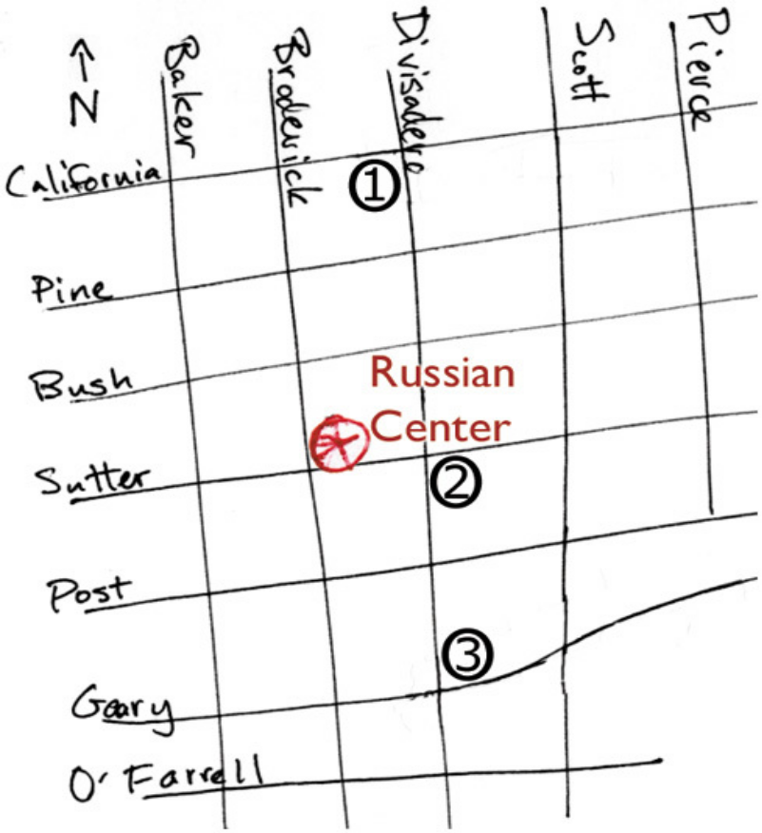

Friday, September 12
Evening: 9pm - 12am, Sutter Room @ the Regency
featuring Barbara Morrison
Late night: 12am - 5am, Sutter Room @ the Regency

Regency Center: 1290 Sutter St (at Van Ness),
San Francisco, CA 94109

Public transit: Because of its central location, the Regency Building is easily accessible by public transportation. Muni bus lines 1, 2, 3, 4, 19, 38, 42, 47, 49 all stop within a few blocks of the facility.
(1) Muni bus # 1 (4) Muni bus # 19
(3) Muni California Line cable car (5) Muni bus # 2, # 3, # 4
(*) Muni bus # 47, # 49, # 76, # 90 (6) Muni bus # 38, # 38L

Driving directions:
From the South Bay: Take the 101 North to the Fell/Mission Street Exit. Turn right off the exit, and left onto Van Ness Avenue. Continue up Van Ness Avenue several blocks to Sutter Street. We are located on the northeast corner of Van Ness & Sutter.

From the North Bay: From the Golden Gate Bridge, take the Lombard Street exit. Continue on Lombard Street to Van Ness Avenue. Take a right turn onto Van Ness Avenue. Continue up several blocks to Sutter Street. We are located on the northeast corner of Van Ness & Sutter.

From the East Bay: From the Bay Bridge, take Highway 80 onto the 101 North. Take the Fell/Mission Street Exit. Turn right off the exit, and left onto Van Ness Avenue. Continue up Van Ness Avenue several blocks to Sutter St. We are located on the northeast corner of Van Ness & Sutter.

Parking:
- ABC Parking, 1399 Polk at Bush, Fri & Sat: 8 a.m. - 2 a.m., 0-120 minutes: $2, 121-180 minutes: $3.50, 3-4 hrs: $5, $14 maximum
- Cathedral Hill Hotel/ Ampco Parking, 1101 Van Ness Avenue at Geary, 24 hrs, $1.20 each 20 minutes, $20 maximum
- U.S. Parking, 855 Geary at Larkin, 24 hours, Fri: $10 for 6 hrs, Sat: $5
- Holiday Inn Golden Gateway Garage, 1500 Van Ness at California, 24 hrs, after 5 p.m. $10
- Sutter Place Garage, 1355/1395 Sutter at Van Ness, 24 hrs, $5 after 6 P.M.
- RT Parking, 80 Hemlock at Polk, Fri: 6:45 a.m. - 1:30 a.m., Sat: 7 a.m. - 1:30 a.m., $1.50 every 20 minutes, $7 maximum

Restaurants:
- (2) 24 hours: Bob's Donut & Pastry Shop, 1621 Polk St (at Sacramento St) (415) 776-3141
- Th-Sat till 2am: Nara Sushi, 1515 Polk St (at California St) (415) 567-1515
- Till 4am: Grubstake, 1525 Pine St (at Polk St) (415) 673-8268
- (6) Fri & Sat 24 hours: Mel's Drive-In, 1050 Van Ness Ave (at Geary) (415) 292-6357
- Till 1:45am: Tommy's Joynt, 1101 Geary Blvd (at Van Ness) (415) 775-4216
- Fri & Sat till 2am: Cilantro, 1051 Geary St (at Van Ness) 415.931.6065
- Fri & Sat till 2am: Olive, 743 Larkin St (at O'Farrell) (415) 776-9814

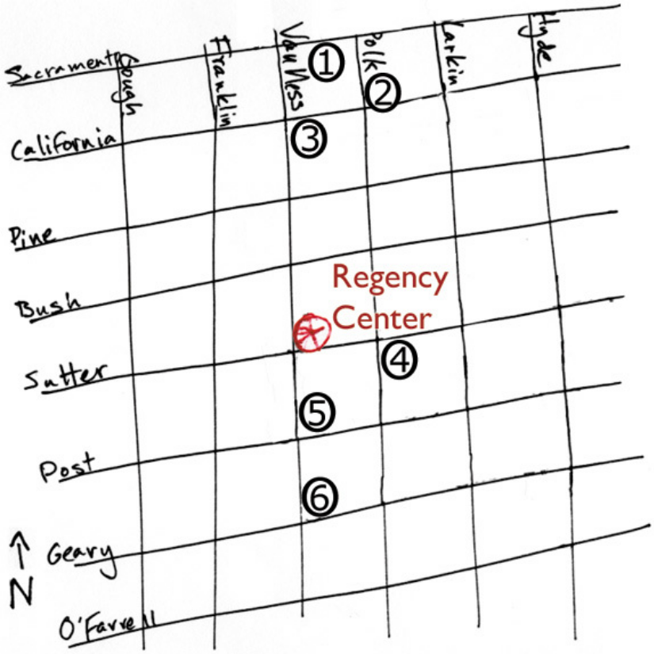

Saturday, September 13
Day: 1pm - 5pm, Justin Herman Plaza (Co-Sponsored by SF Bal Fest)
Evening: 9pm - 12am, Grand Ballroom @ the Regency
featuring Fil Lorenz Orchestra w/ Connie Champagne
Late night: 12am - 5am, Grand Ballroom @ the Regency
Featuring The Dave Workman Band with special guest John Broadway Tucker

Justin Herman Plaza: 1 Market St (at Steuart), San Francisco, CA 94105

Public transit: Muni Metro & BART: Exit Embarcadero (& Market Street)
(1) & (2) & (3). Muni buses 1, 2, 7, 12, 14, 20, 21, 38, 38L, 41, 66, 71; California Line cable car; F-Castro Streetcar

Driving Directions:
From the South Bay: From the 101N, take the 4th Street exit, which will place you on Bryant Street heading east. Turn left on Main Street. Proceed down Main Street to Market Street veer right across Market. Main then becomes Drumm Street. The Hyatt Regency Hotel is on the right. Justin Herman Plaza is east of the Hyatt, and faces The Ferry Building.

From the North Bay: From the Golden Gate Bridge, take the Lombard Street exit to Van Ness Avenue. Make a right on Van Ness and then go 1/2 mile and make a left on California Street. You will go over Nob Hill and at the bottom of the hill make a left on Kearny Street. Make a right on Clay St.

From the East Bay: From the Bay Bridge, exit Hwy 80 at Fremont Street, the first exit on your right as you come into San Francisco. Stay on Fremont Street. Cross over Market Street which will then become Front Street. Continue on Front Street to Sacramento Street.

Parking is very limited:
(1) Embarcadero Center, enter from Clay Street or Sacramento Street and Davis Street, or on Battery. Hours 7am-Midnight.

Weekend Validation (10:00 a.m. - 12:00 a.m.) 4 hours free parking with validation from retail stores, restaurants, EC Cinema, optometry and dental offices ($5 minimum purchase).

Parking without Validation Weekend Rates (7:00 a.m. -
12:00 a.m.) Per Hour: $3.00, Daily Maximum (24 hours): $30.00

Restaurants & Shops: (1) Embarcadero Center, (2) Ferry Building

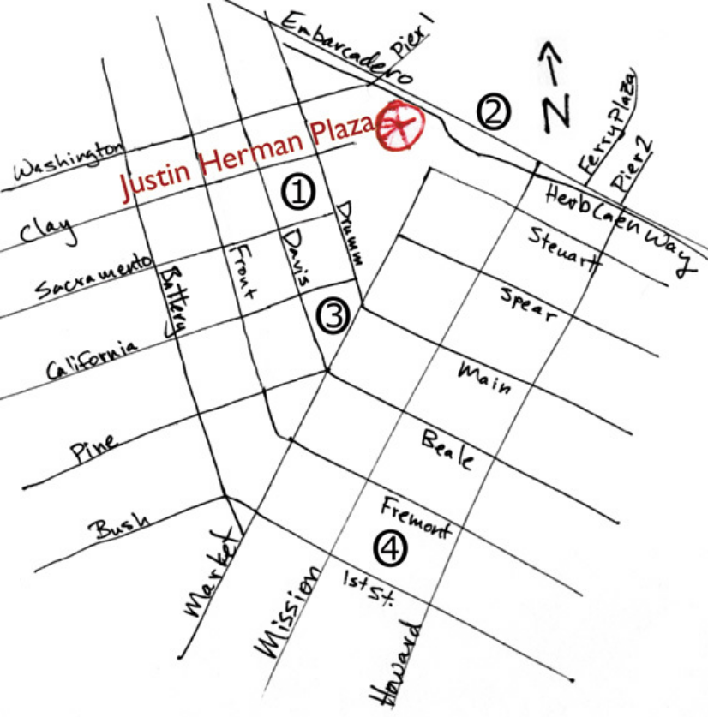

Sunday, September 14
Day: 11am - 3pm, Lindy In The Park
Evening: 8pm - 12am, CCSF Community Health & Wellness Center,
featuring Jelly Roll Souls
Late night: 12am - 5am, Hines Solarium

Golden Gate Park: John F Kennedy Drive, between 8th & 9th Ave (follow signs to The de Young Museum and Japanese Tea Garden)

Public Transit:
(1) Muni bus # 5, # 21 (exit 8th Ave & Fulton)
(2) Muni bus # 44 (exit Tea Garden Drive/Academy of Sciences)
(3) Muni Metro N-Judah (exit 9th Ave & Judah)

Driving Directions:
General Notes: On Sundays, John F Kennedy Drive will be closed from Tea Garden Drive to Transverse Drive, and street parking within the park will be severely limited. Tea Garden Drive, entering from south of the park, will be open for drop off and pickup of passengers.

From the South Bay/I-280 North: From Hwy 1 North, exit on 19th Ave. 19th Ave runs through Golden Gate Park and turns into Park Presidio at Crossover Drive. From Park Presidio, turn Right onto Fulton St. to 8th Ave.

From the North Bay: From the Golden Gate Bridge take the 19th Ave/Park Presidio Blvd exit and proceed through the tunnel onto Park Presidio Blvd. Go two miles to Cabrillo St. Turn Right on Cabrillo, then Right again on 14th Ave. Proceed one block north to Balboa St., turn Right. Proceed across Park Presido Blvd. to 8th Ave.

From the East Bay: From the Bay Bridge, exit at Fremont St.. Turn Left onto Fremont St., then Left onto Pine St. Take Pine St. for 2.7 miles past Presidio Ave. and bear Left onto Masonic Ave. Follow Masonic Ave. for 0.8 miles and make a Right turn onto Fulton St. Follow Fulton for 1.3 miles to 8th Ave.

Parking: Street parking is available in the neighborhood north of Golden Gate Park.
Music Concourse Garage: Access to the north entrance of the Music Concourse Parking is from Fulton St. at 10th Ave. Access to the south entrance is at Concourse Dr. and Martin Luther King Dr. inside the park. $3/ hour.

Restaurants & shops: (1) Safeway Supermarket 735 7th Avenue (between Fulton St & Cabrillo St). (4) Shops, restaurants, ATMs, etc.

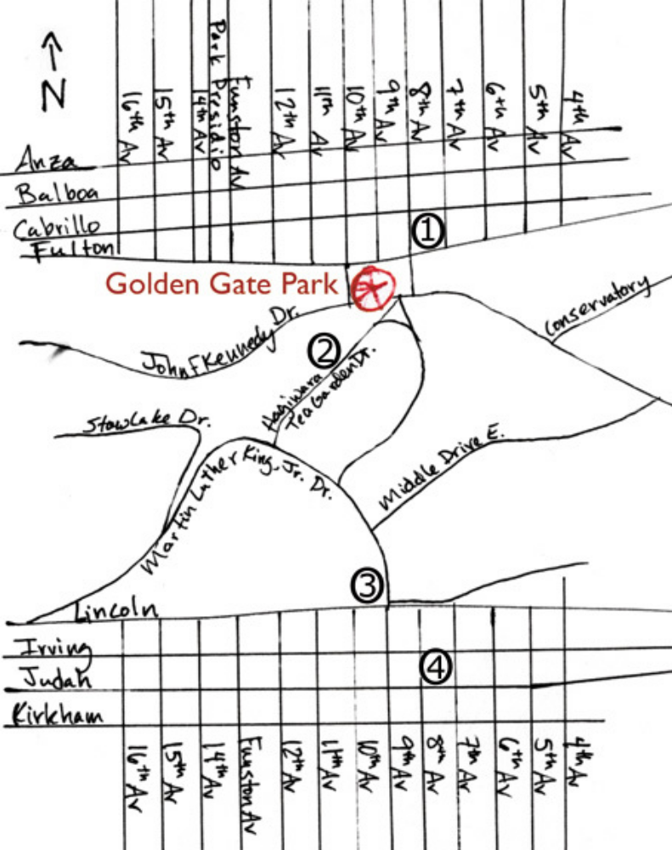

City College of San Francisco: Community Health & Wellness Center, Performance Theater, Room 301; 50 Phelan Ave (at Ocean Ave), San Francisco, CA 94112

Public transit:
(3) Muni Metro K, K-Owl (late night)
(4) Muni bus # 9AX, # 9BX, # 9X, # 26, # 29, # 36, #43, # 54, # 91
(5) Muni bus # 26, # 36, # 49, # 95
(BART) Balboa Park station (San Jose Ave, b/t Ocean & Geneva): BART; Muni Metro F, J, M; Muni bus # 88

Driving Directions:
From South Bay: From Hwy 280 North East, turn Left at Geneva Ave exit. Follow Geneva Ave across to Phelan Ave. Parking lot will be on your Left, the campus will be on your Right.

From East Bay: From the Bay Bridge, take Hwy 101 South to Hwy 280 South. Exit at Ocean Ave, turn Right. At second light, turn Right onto Phelan Ave. Parking lot will be on your Left, the campus will be on your Right.

From North Bay: From the Golden Gate Bridge, take Hwy 1 South, which becomes Park Presidio Blvd and runs through Golden Gate Park to 19th Ave. Turn Left onto Sloat Blvd, then Right onto Junipero Serra Blvd. Turn Left onto Ocean Ave. After 1.2 miles, turn Left onto Phelan Ave. Parking lot will be on your Left, the campus will be on your Right.

Parking: Five lots marked (P) are available on campus. Visitors may purchase a one-day permit for parking in student lots only. These permits are dispensed from machines located in the lots and cost $2.

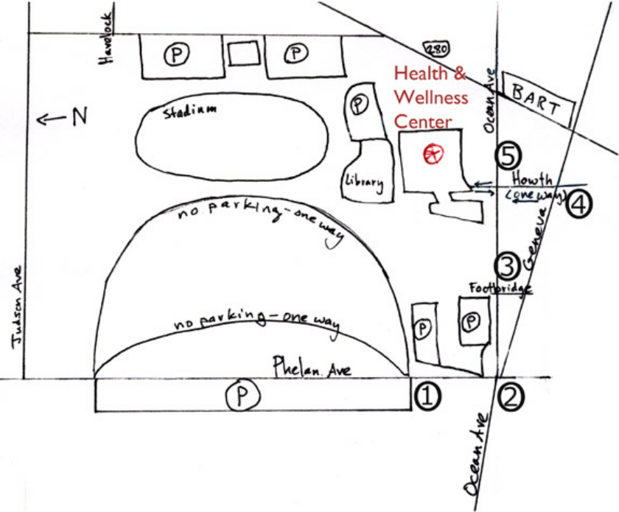

Hines Solarium: KPMG Building, 55 2nd Street; San Francisco, CA 94105

Public transit:
(1) Montgomery Station: BART, Muni Metro J, K, L, M, N, S, T
Muni on Market St: buses # 2, 5, 6, 7, 9, 21, 31, 38, 38L, 71, 71L; F Street car; Late night L-Owl, N-Owl, T-Owl. Muni buses crossing Market St: # 1, 3, 4, 9AX, 9BX, 9X, 10, 20, 30, 41, 45. Muni bus # 14 runs along Mission St. (2) Transbay Terminal: Muni bus # 108, AC Transit bus # 800 and lettered lines for transbay service (see in-station guide for details).

Driving Directions:
General Notes: Second is a two-way street. No left turns onto Second Street are permitted on Market Street. No left turns onto Second Street are permitted on Mission Street. Anthony Street is between First and Second Streets (off Mission Street)

From the South Bay: Take the 101 North to 4th Street (the last San Francisco Exit). Turn Left onto Bryant Street, then Left onto 2nd St. The Solarium will be on your Left, just after Stevenson Street.

From the East Bay: From the Bay Bridge, exit from Highway 80 at Fremont Street, turning Left onto Fremont. Turn Left onto Howard Street, then Right onto 2nd Street. The Solarium will be on your Right, just before Stevenson Street.

From North Bay: From the Golden Gate Bridge, take the Lombard Street exit. Continue on Lombard Street to Van Ness Avenue. Take a right turn onto Van Ness Avenue. After about a mile, turn Left onto Post Street. After about two miles, turn right onto 2nd Street, crossing over Market Street. The Solarium will be on your Left, just after Stevenson Street.

Parking: There should be lots of available street parking.
If you don't mind the walk: Fifth & Mission (across from the Metreon; other entrance on Minna b/t 4th & 5th) 24 hours, Rates: $3/hour, $30 maximum. While the Palace Hotel Garage is open 24 hours, the cost runs to $38 for three hours, and $48 for four or more.

24 hour restaurants:
(3) Lori's Diner, 149 Powell St (at O'Farrell) (415) 677-9999
Mason St is 1 block West of Powell St:
White Horse Restaurant, 635 Sutter St (at Mason) (415) 673-9900
Naan-N-Curry, 336 O'Farrell St (at Mason) (415) 346-1443
Cafe Mason, 320 Mason St (at O'Farrell) (415) 544-0320
Pine Crest Diner, 401 Geary St (at Mason) (415) 885-6407



